Title of the risk analysis
Short descriptive title for the risk analysis
Dato of the analysis
Owner of the risk analysis
Unit where the risk analysis is performed
Leader of analysis
Name and function of the facilitator of the analysis
Participants
Name and function of the participants in the analysis
Background and purpose
Why do you want to carry out a risk analysis? What is the goal?
Description of object of analysis
Give a description of what is to be analyzed.
Location
Address / room number / geographical location for object of analysis
Assumptions and boundaries/limitations
Are any assumptions made? What is not included in the risk analysis?
Comments
Any comments on the analysis?

# | Possible undesired event  and causes | Consequences | Existing measures  and suggested new measures | Probability/likelihood  (1-5) | Consequence  (A-E) |  |  |  |  | Placement in  risk matrix  (number, letter)
 |  |  |  |  | Life & health | Environment | Operation | Economic | Reputation | Placement in  risk matrix  (number, letter)
Existing:

New:
Existing:

New:
Existing:

New:
Existing:

New:
Existing:

New:
Existing:

New:
 | Make new rows as needed |  | Existing:  New:

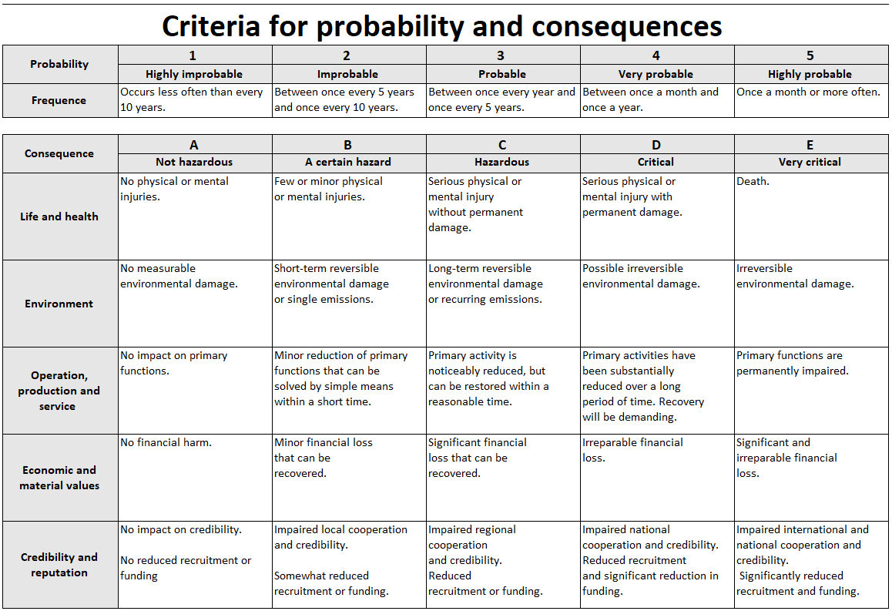
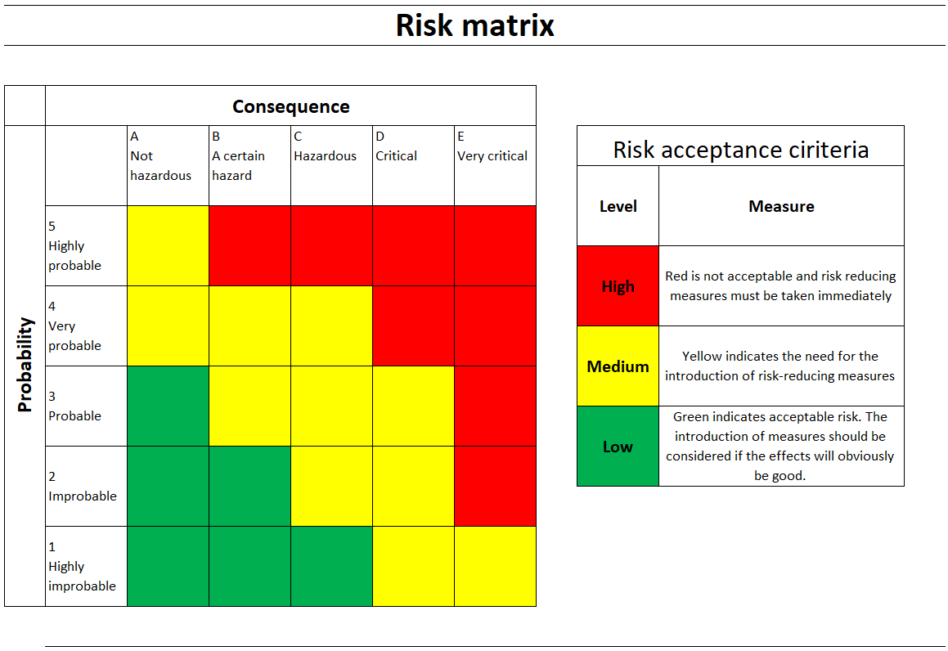
# | New measures | Implementation of measures - description | Responsible for implementation | Status
 | Make new rows as needed

